**240840325020 – Chinmayee Patil**

**CLOUD**

1. Creating an IAM user named **User1**

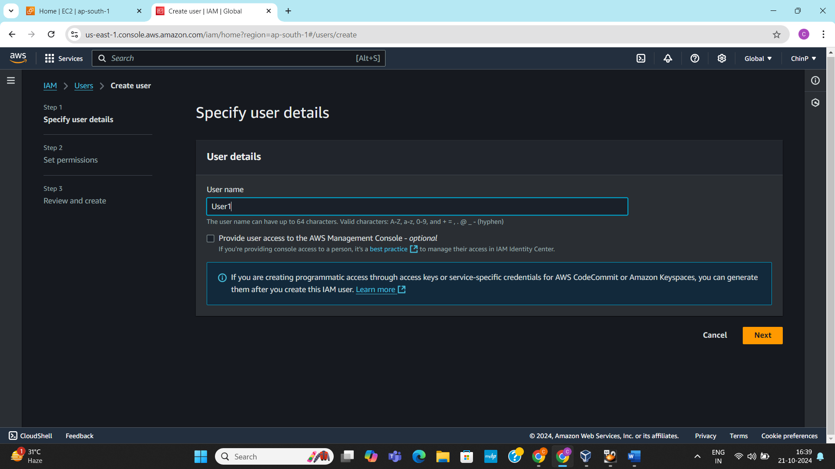

1. Setting the permissions for the user

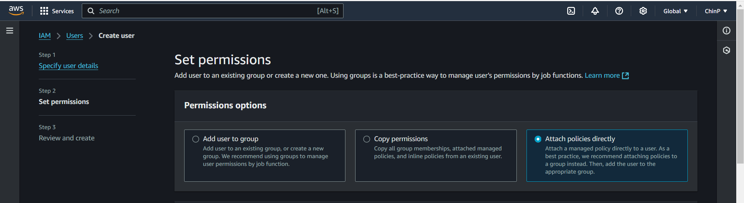

1. Reviewing and creating the user

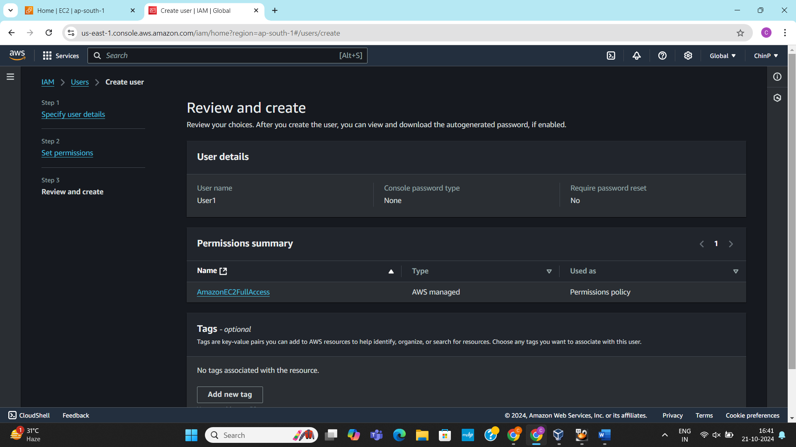

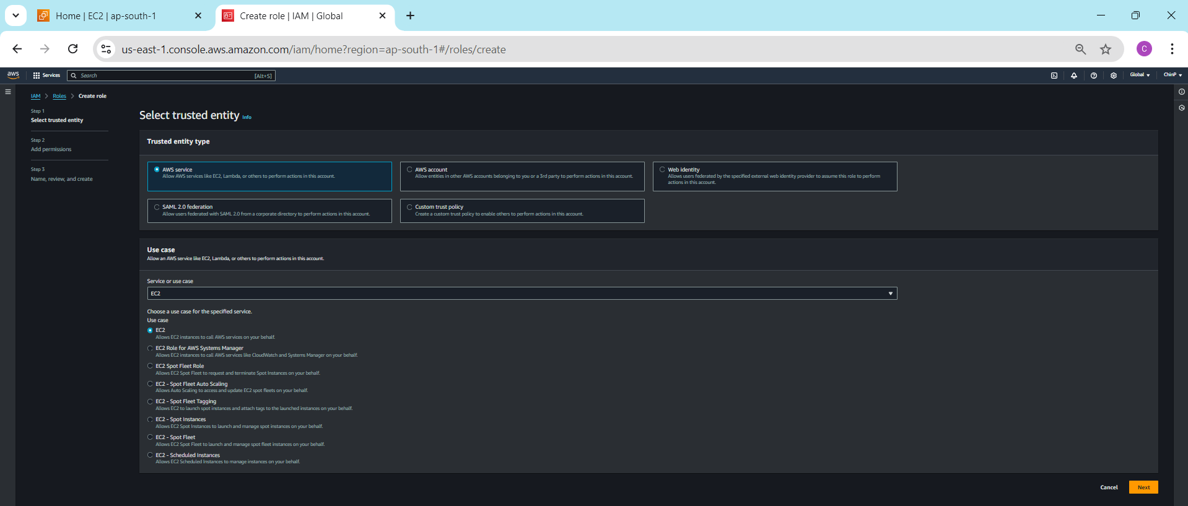

1. Creating a new custom IAM role where user can launch and manage EC2 instances.

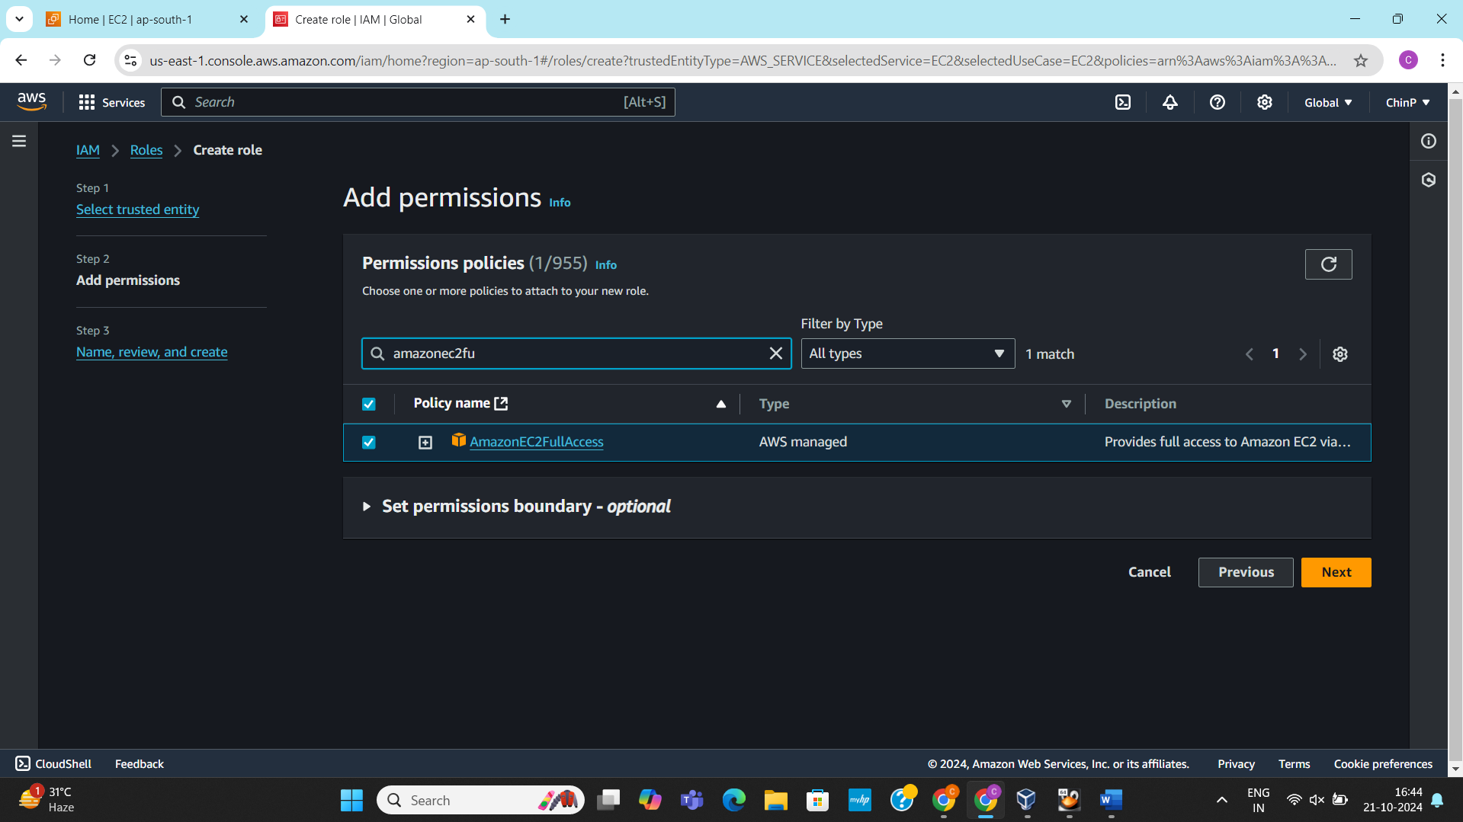

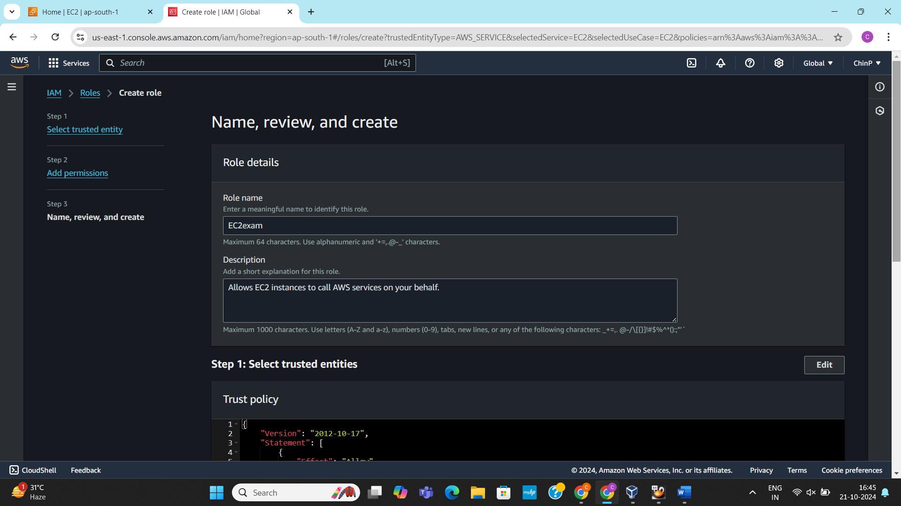

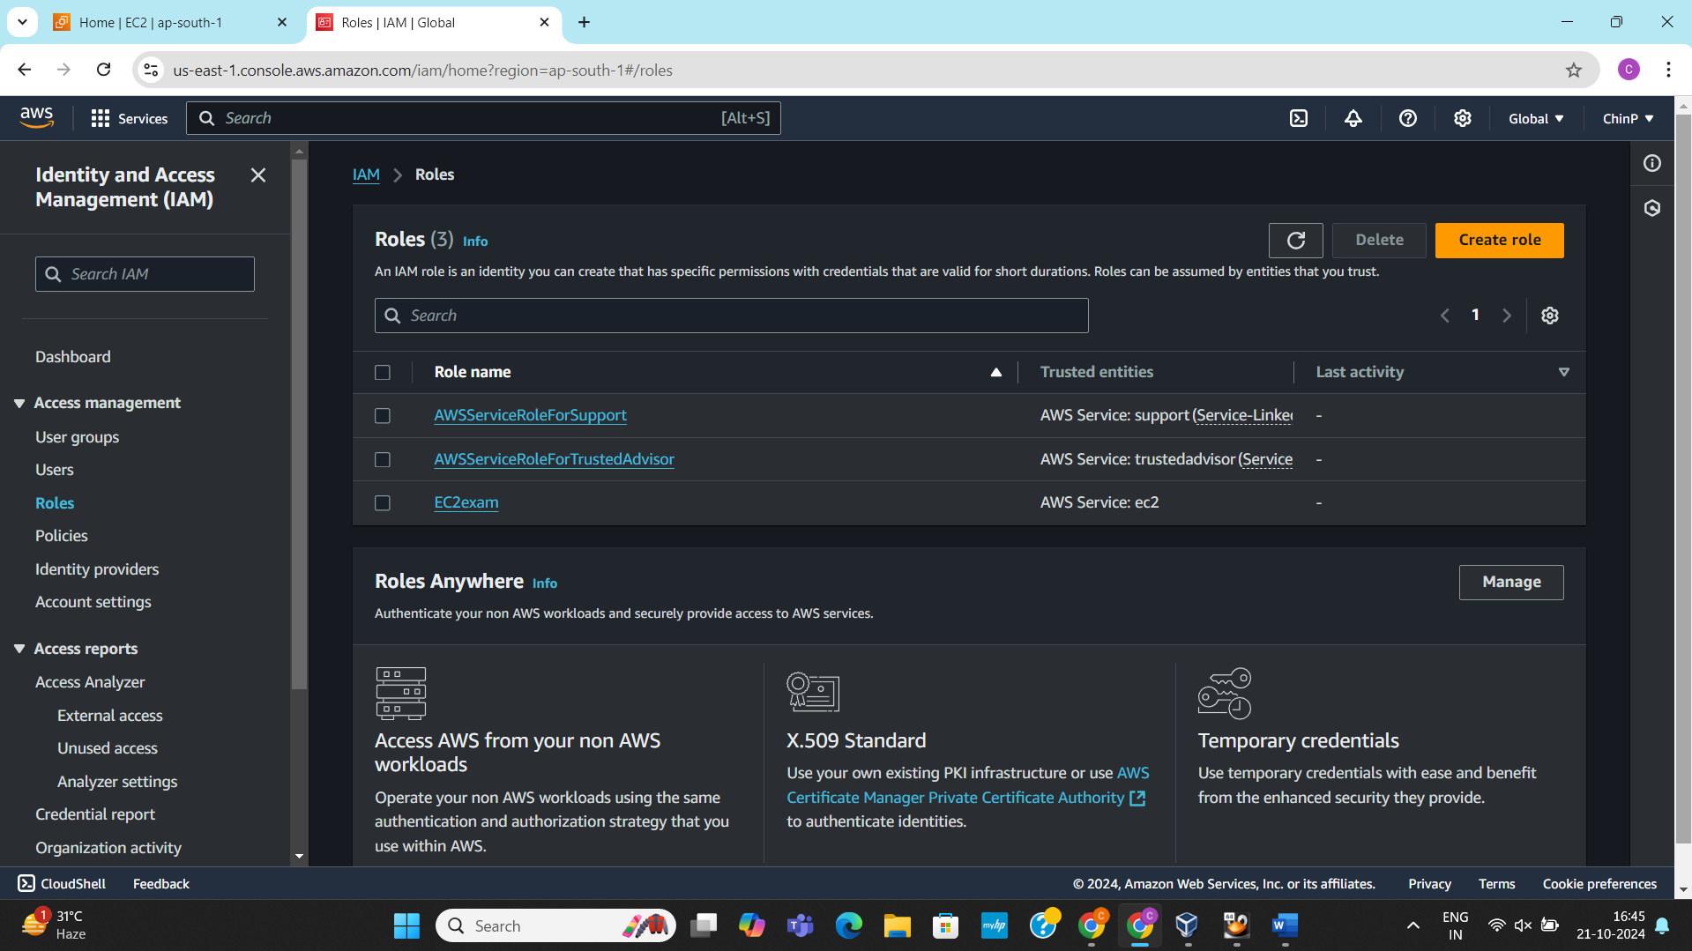

1. Launching an new instance named **LinuxExam** and selecting an AMI.

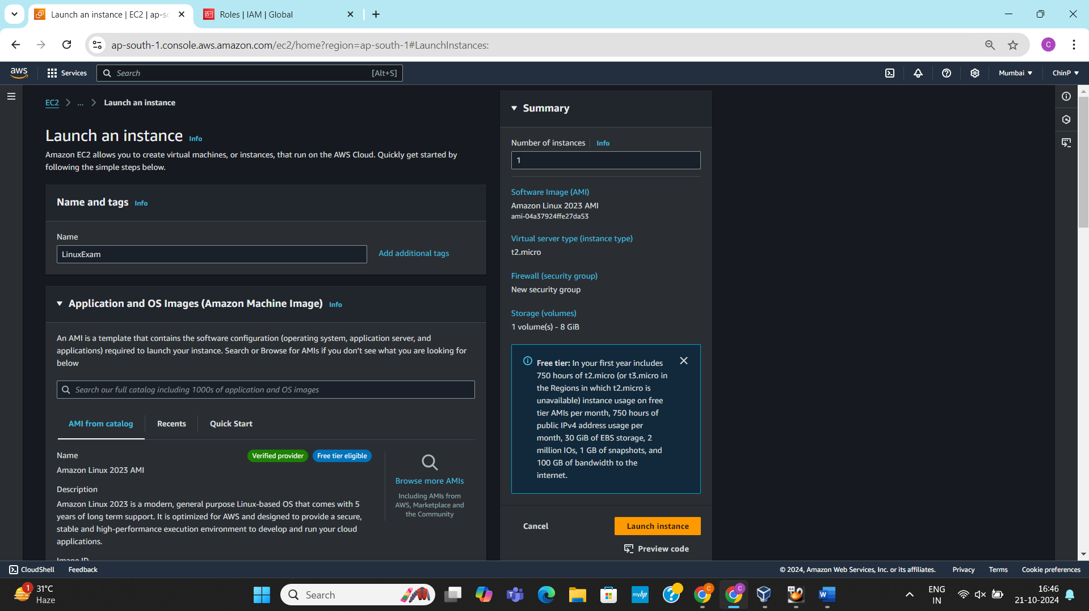

1. Creating a key-pair for the instance

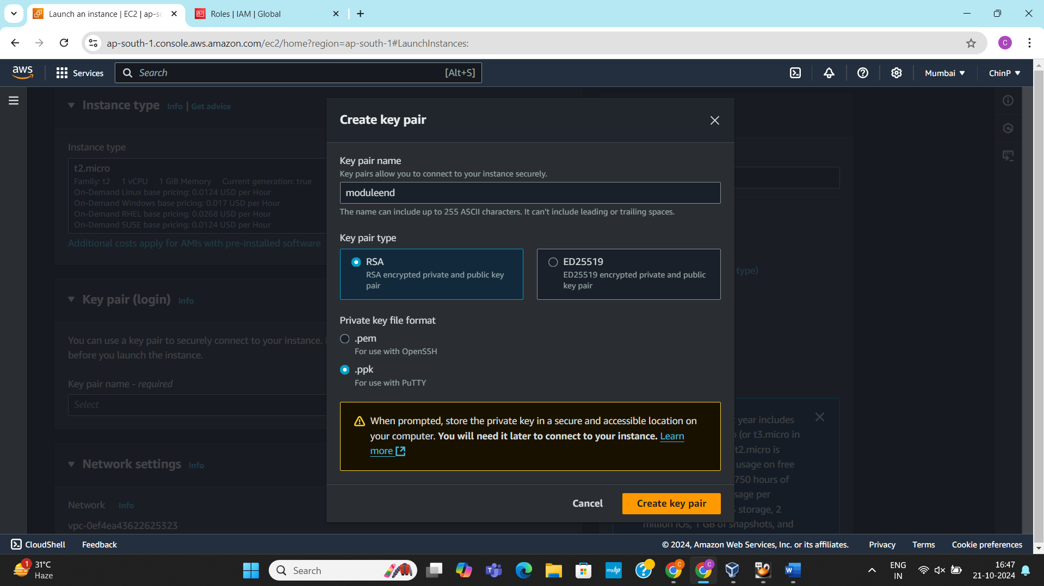

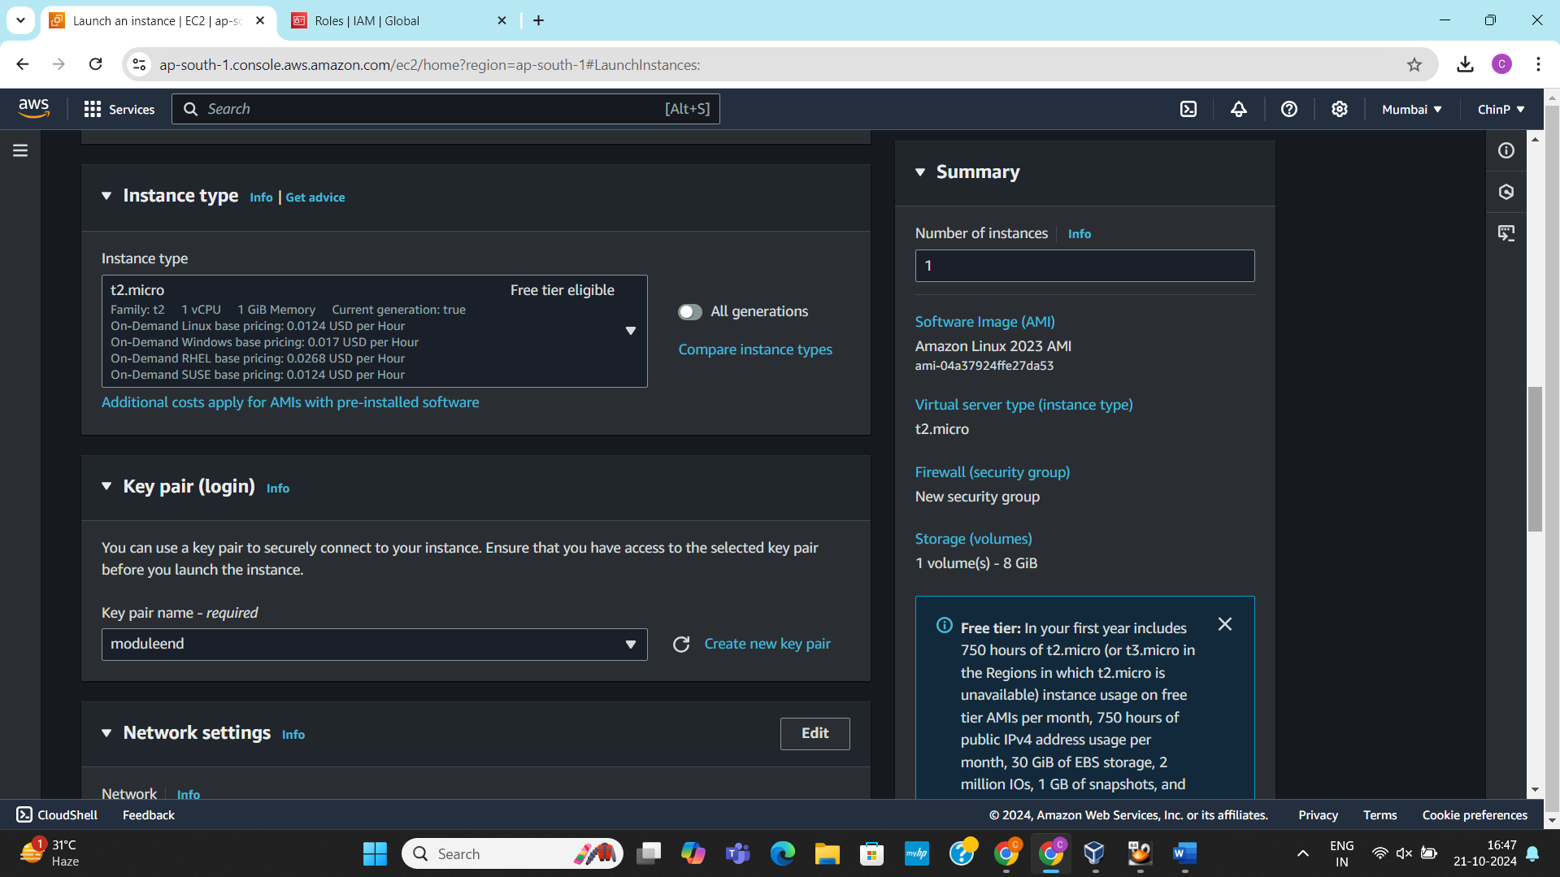

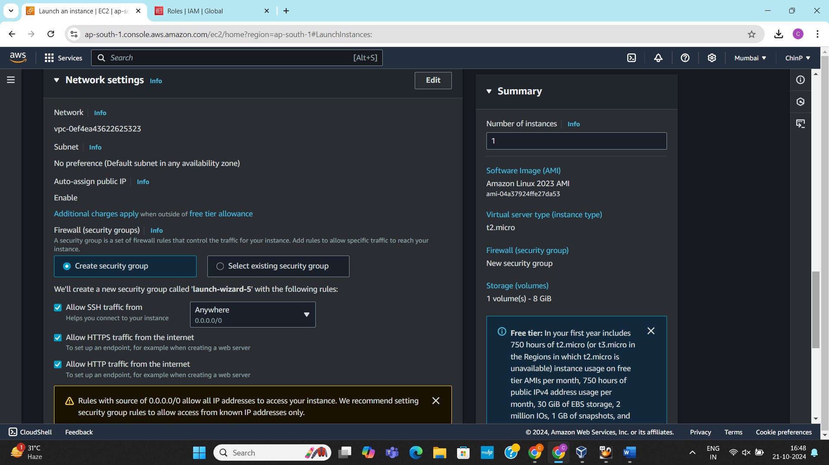

1. Instance created.

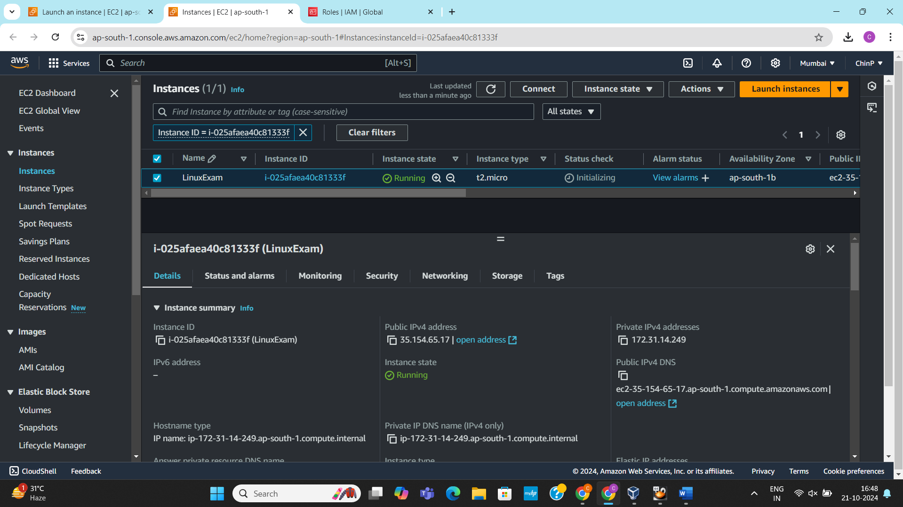

1. Will assign the IAM role to the newly created instance.   
   First we will navigate to the instance.  
   Then we will navigate to the Actions 🡪 Security 🡪 Modify IAM Role

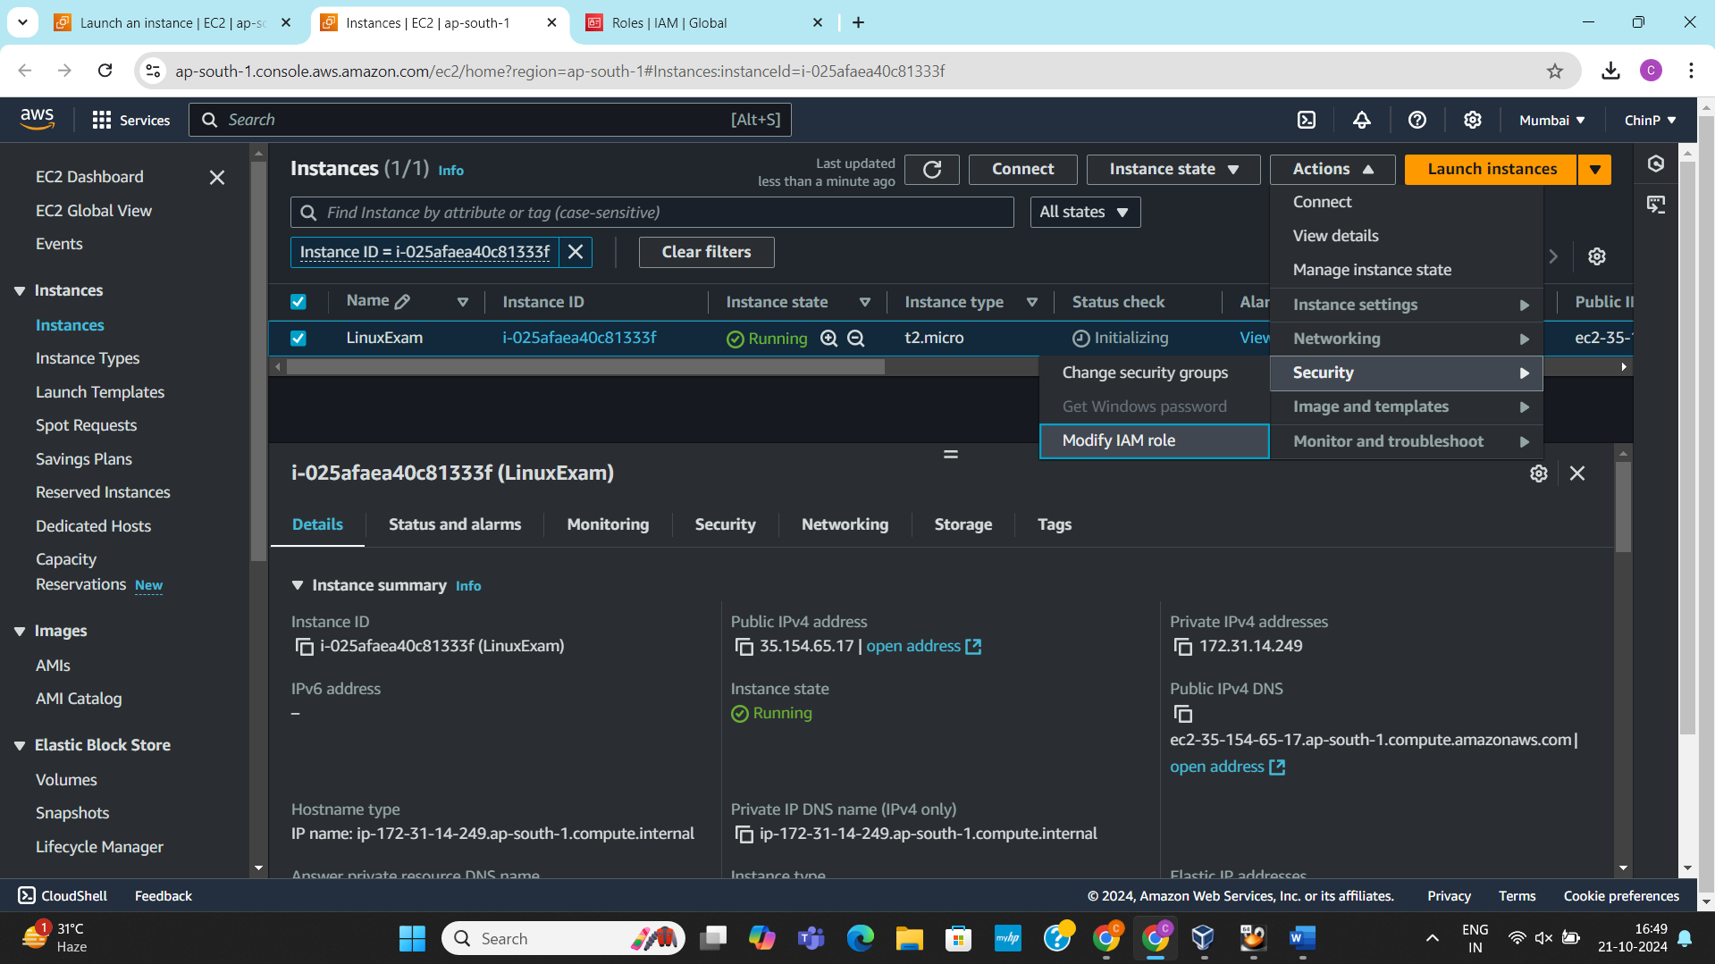

1. Updating the IAM role to the instance

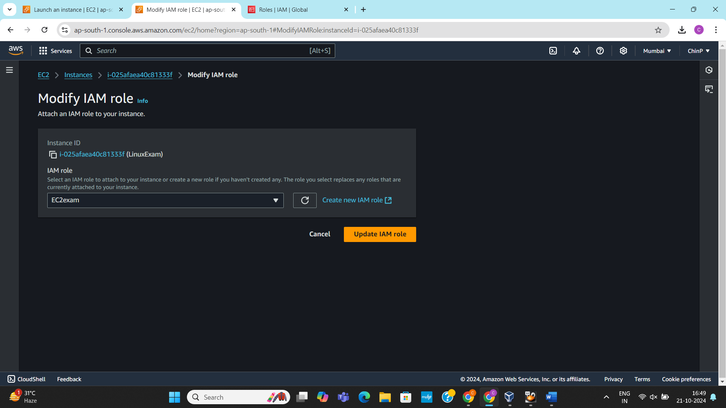

1. Connecting the instance via Putty using Public IP address

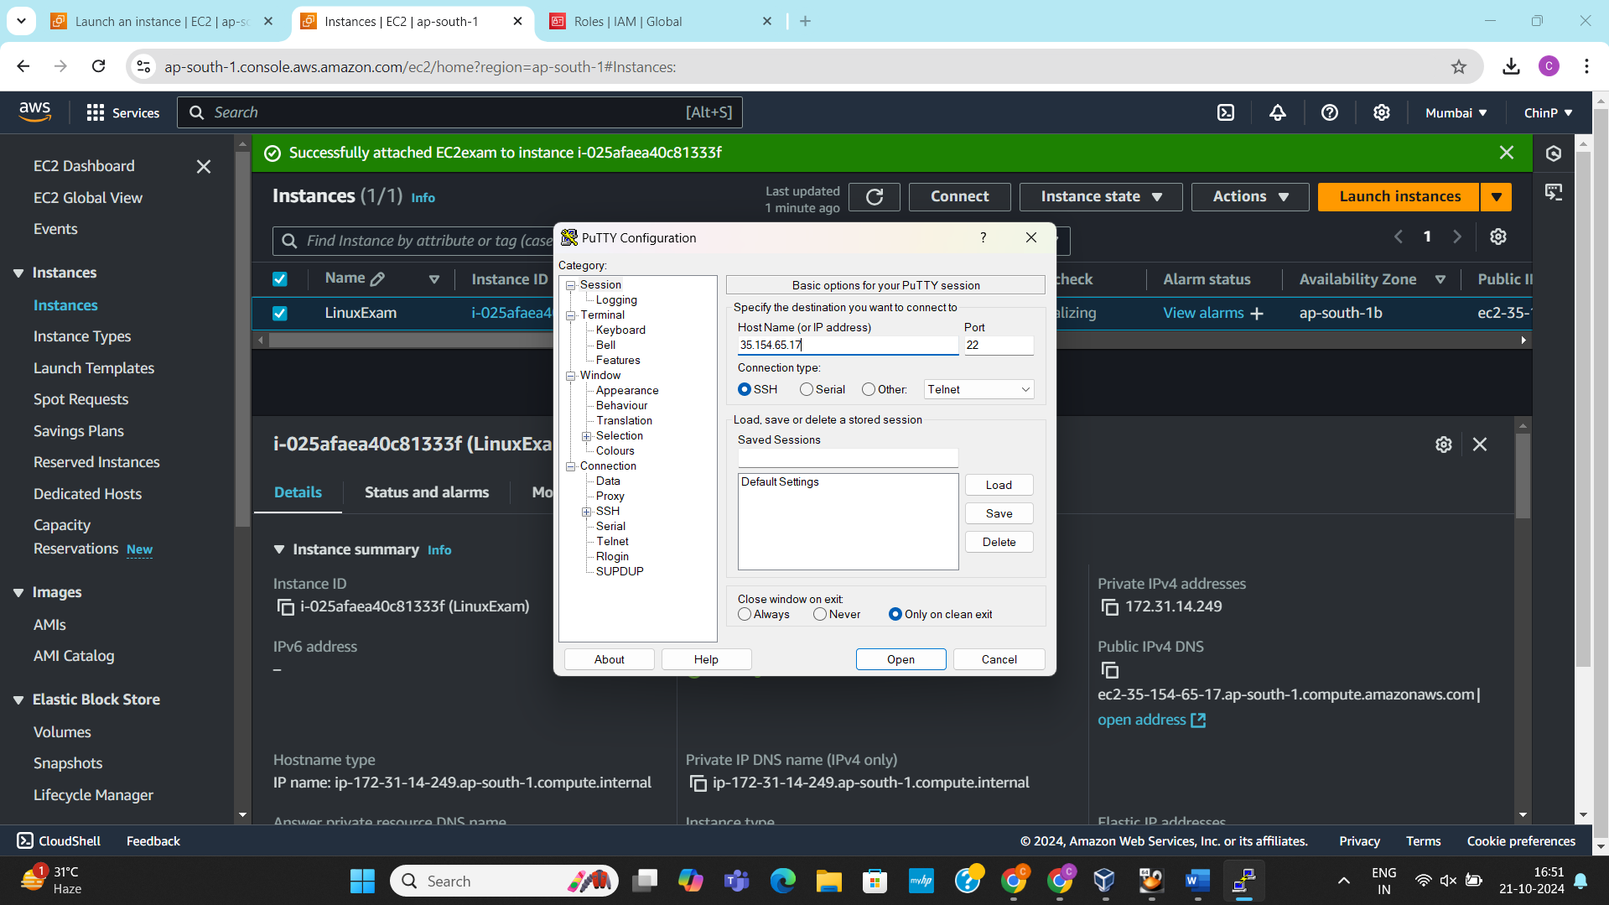

1. Connecting the PPK key

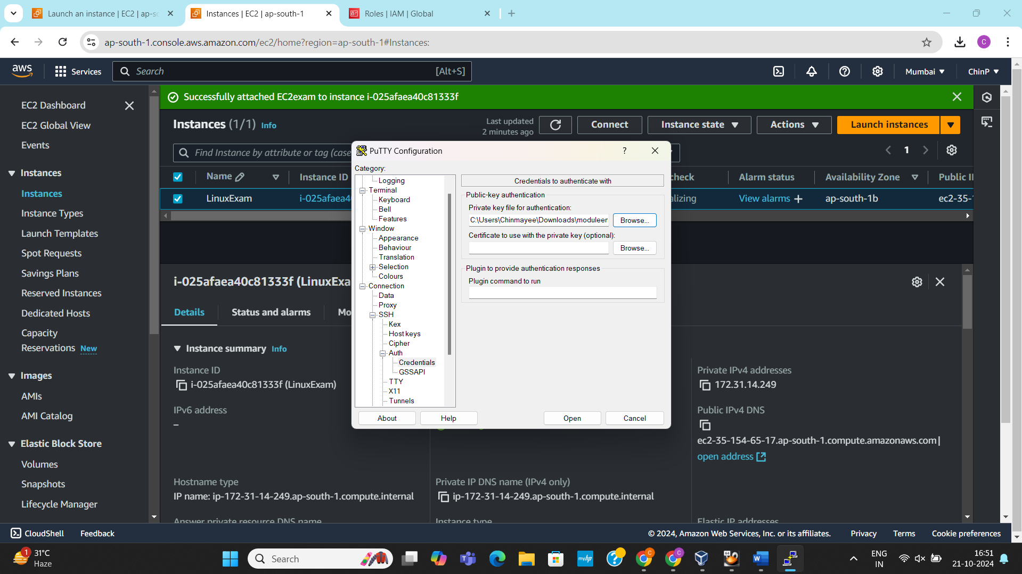

1. Connecting to the instance.

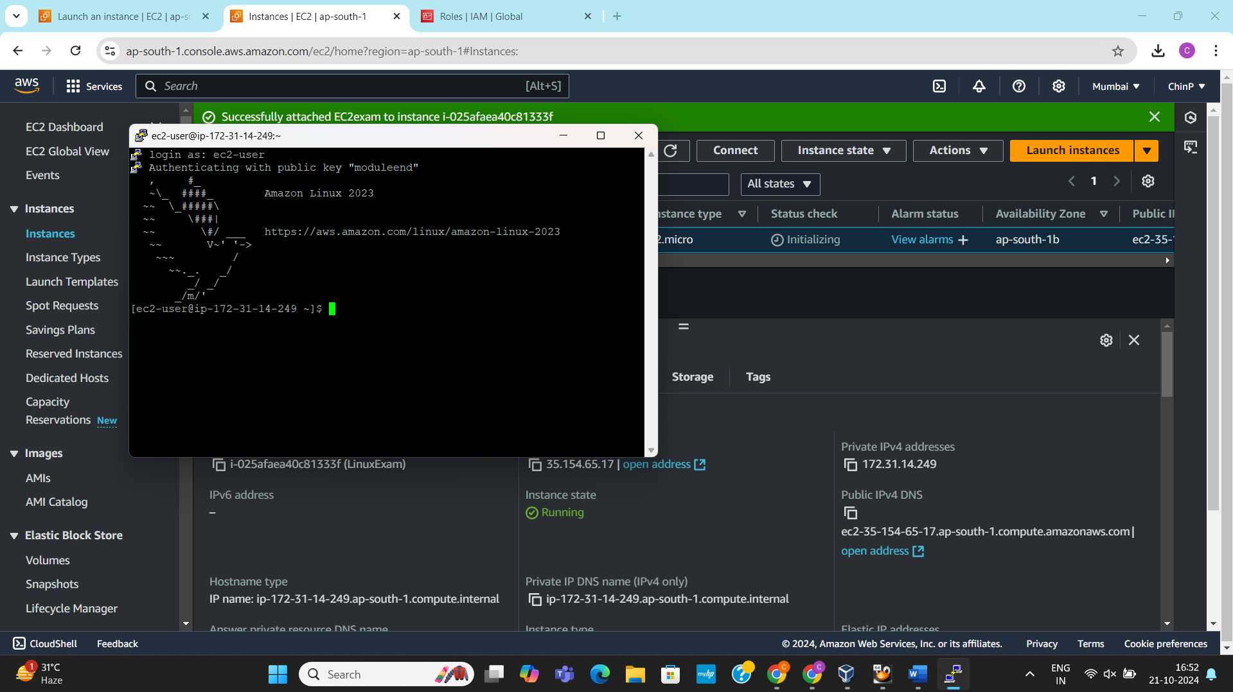

**Creating an S3 Bucket**

1. Create an S3 bucket named mybucketcp

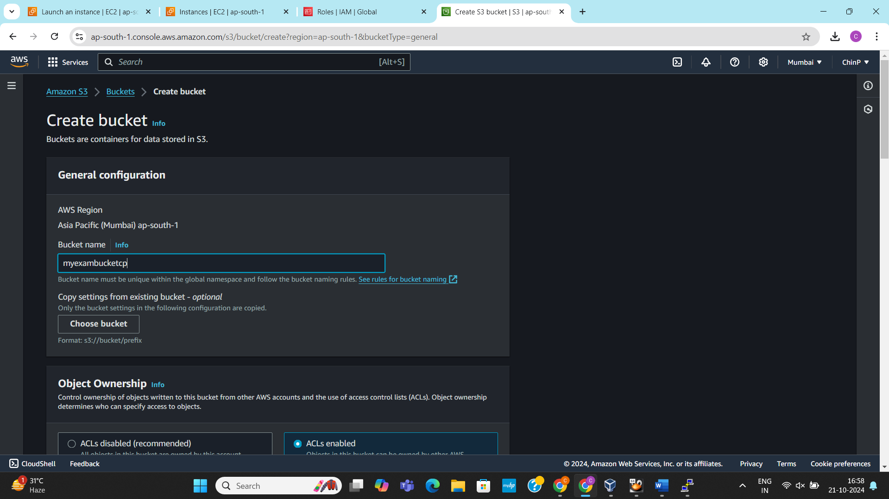

1. Enabling the ACL access

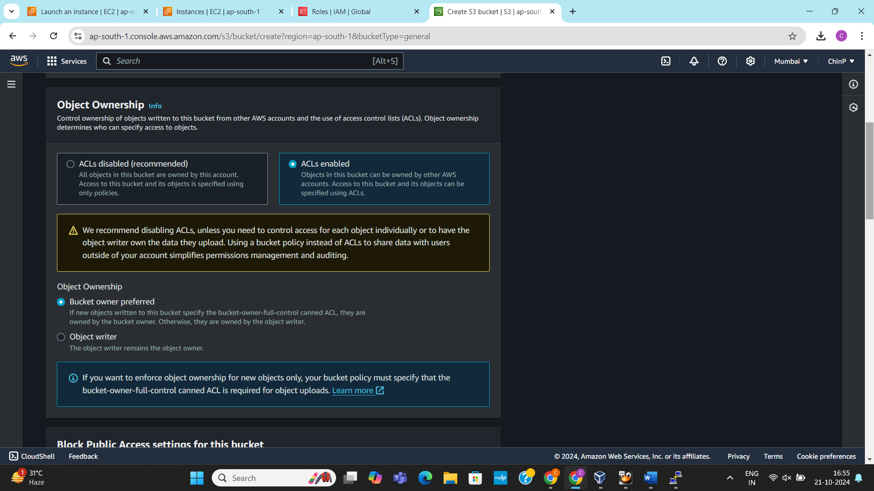

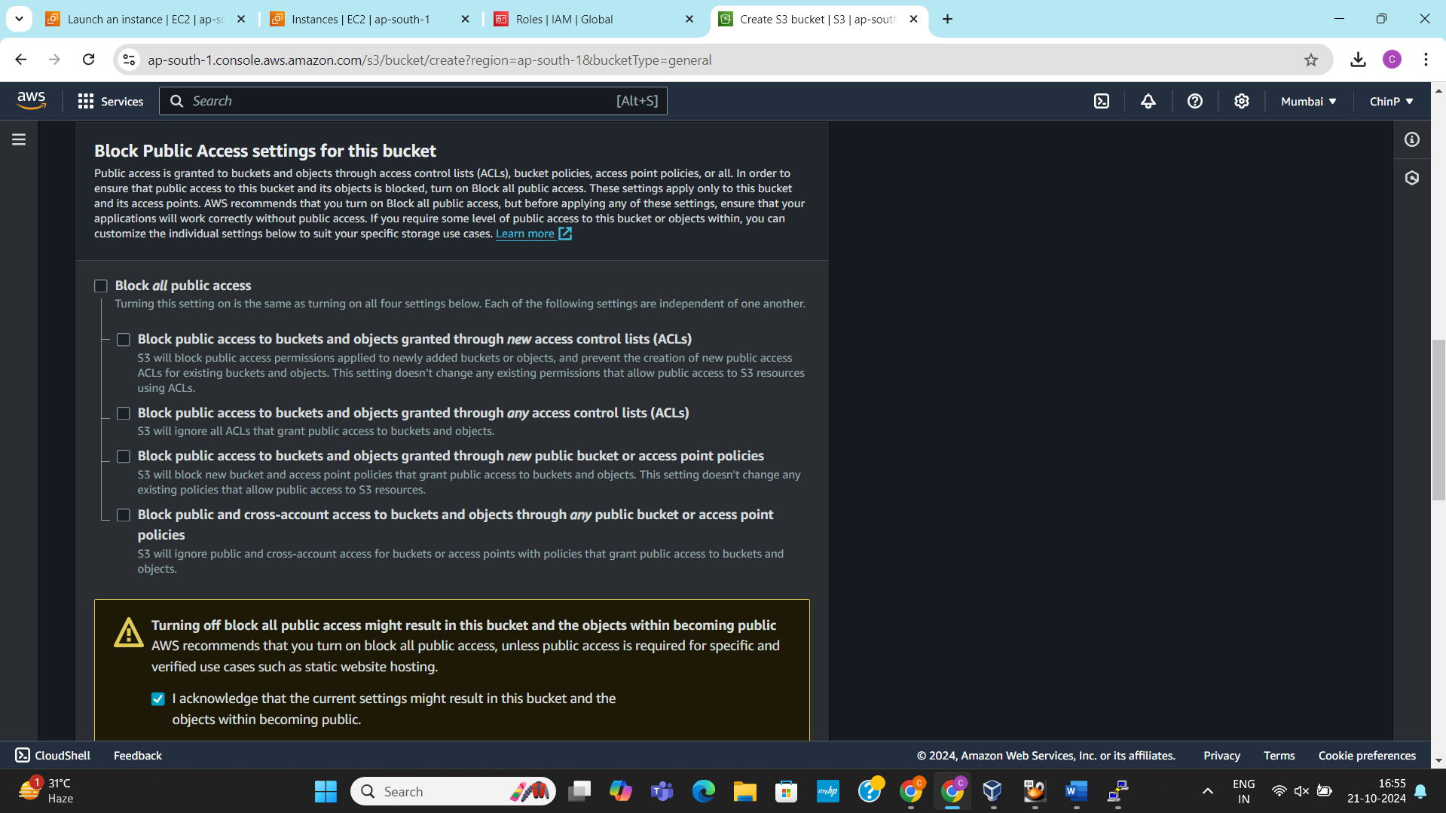

1. Enabling the versioning

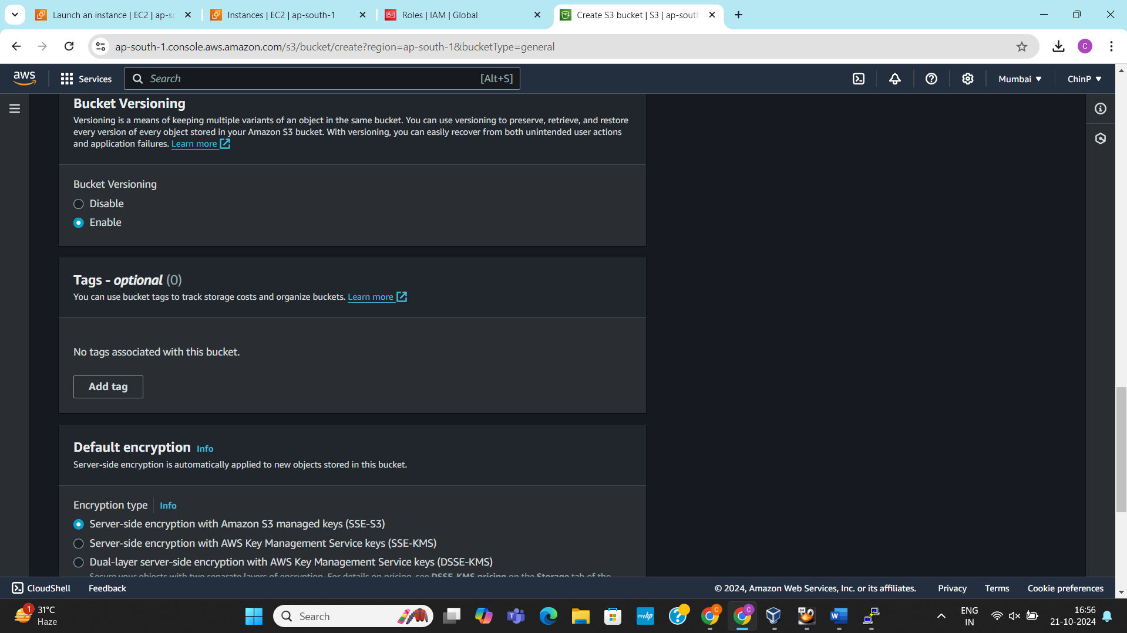

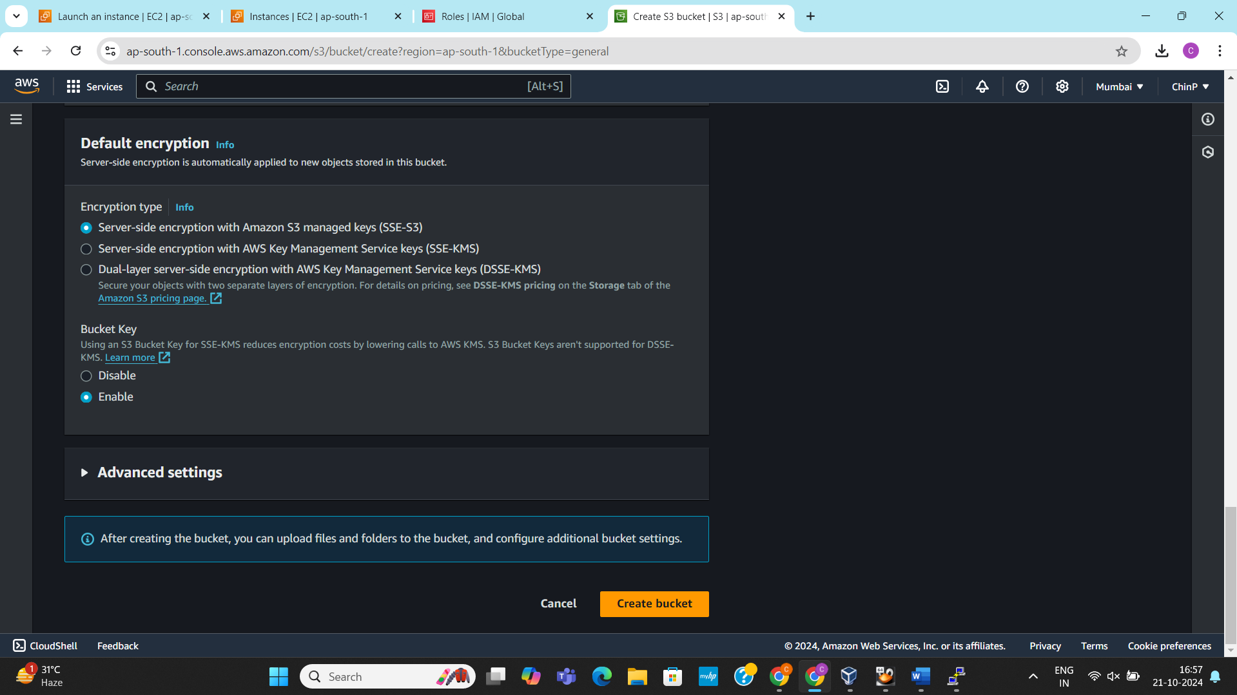

1. S3 Bucket created successfully.

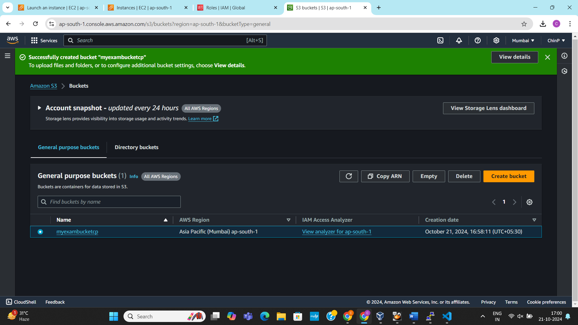

1. Creating an HTML file and uploading it to the newly created bucket.

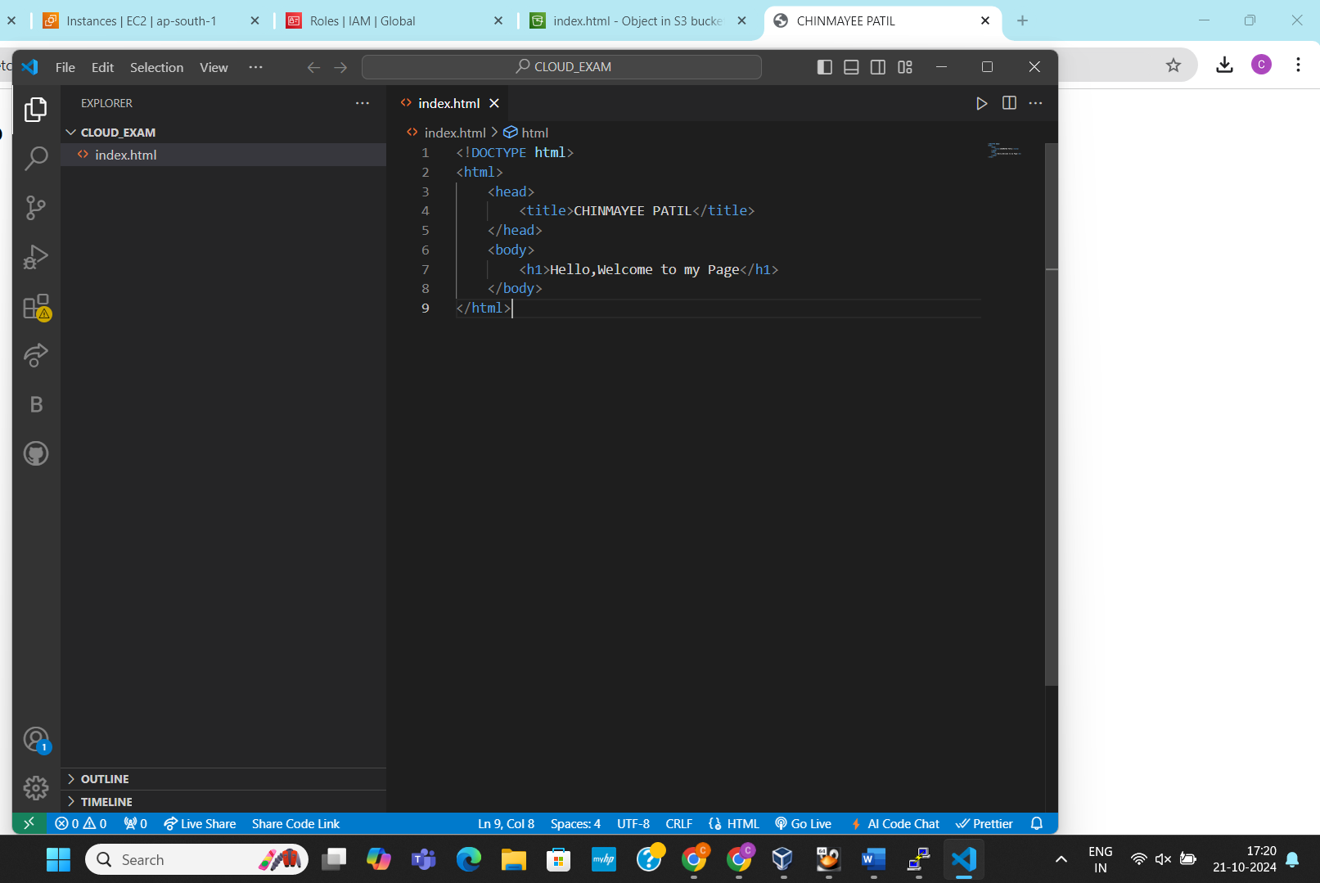

1. Uploading the HTML file to the S3 bucket

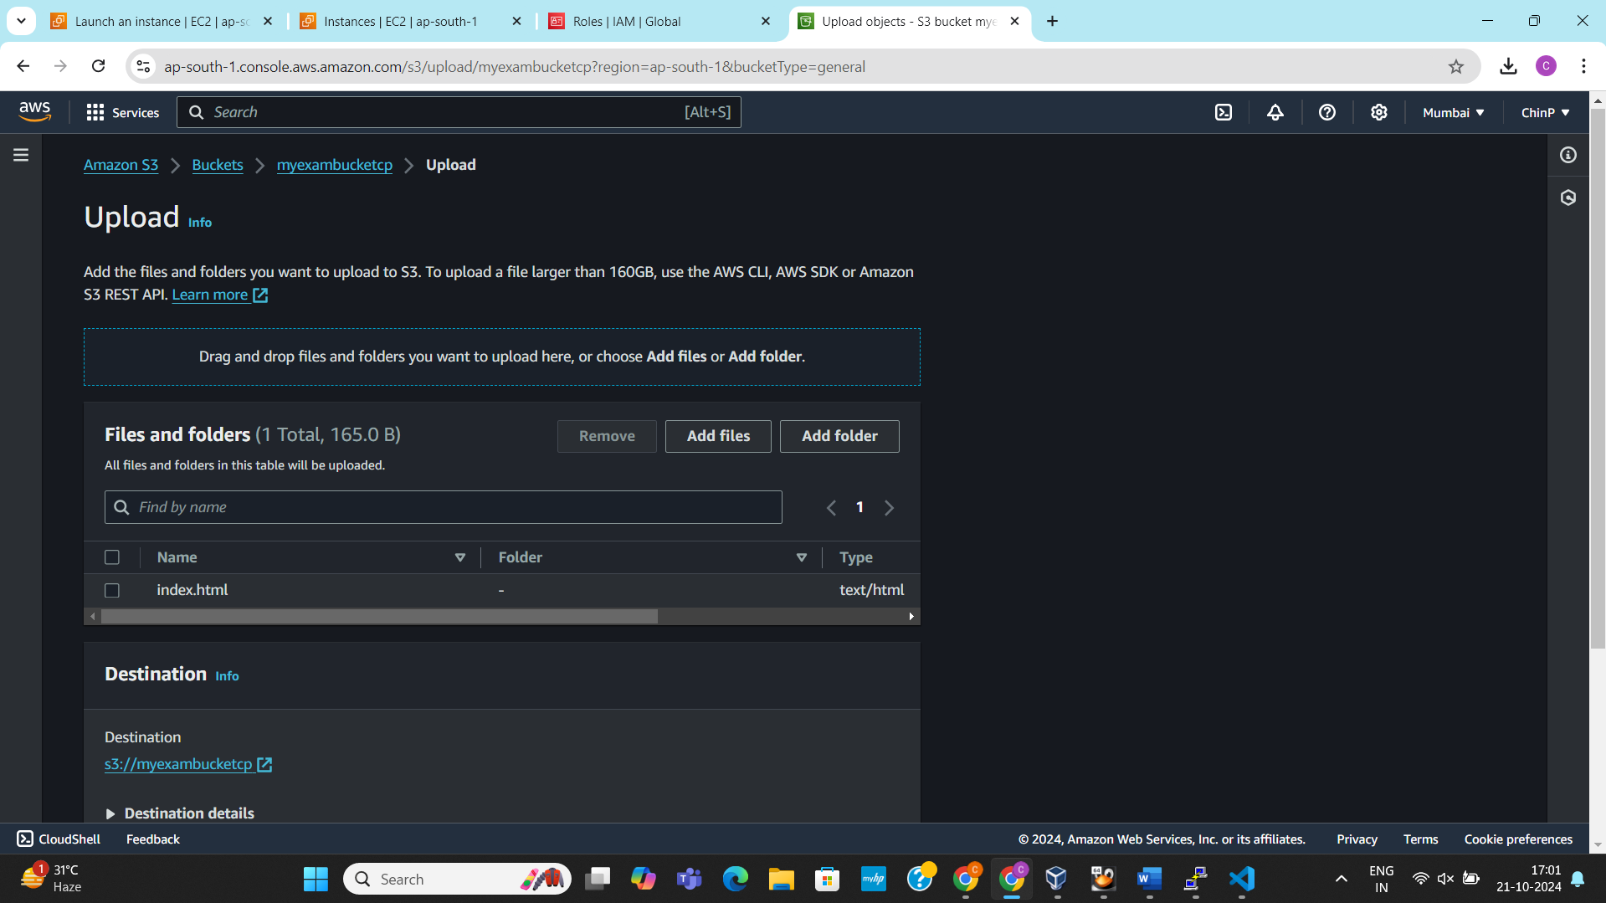

1. File uploaded successfully

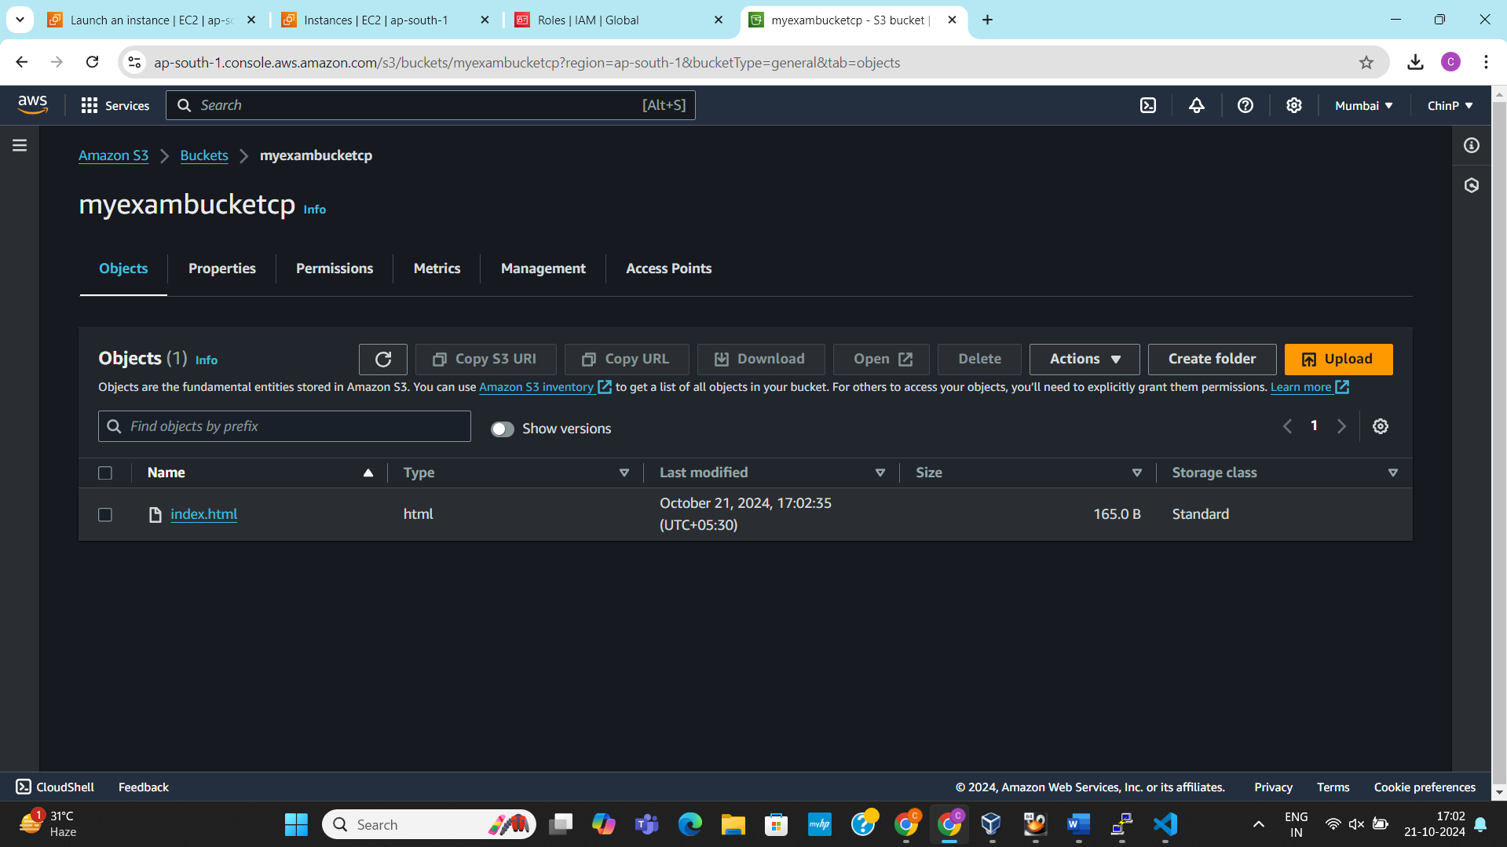

1. Enabling the ACL permissions so that it can be accessible by visiting its Object URL.

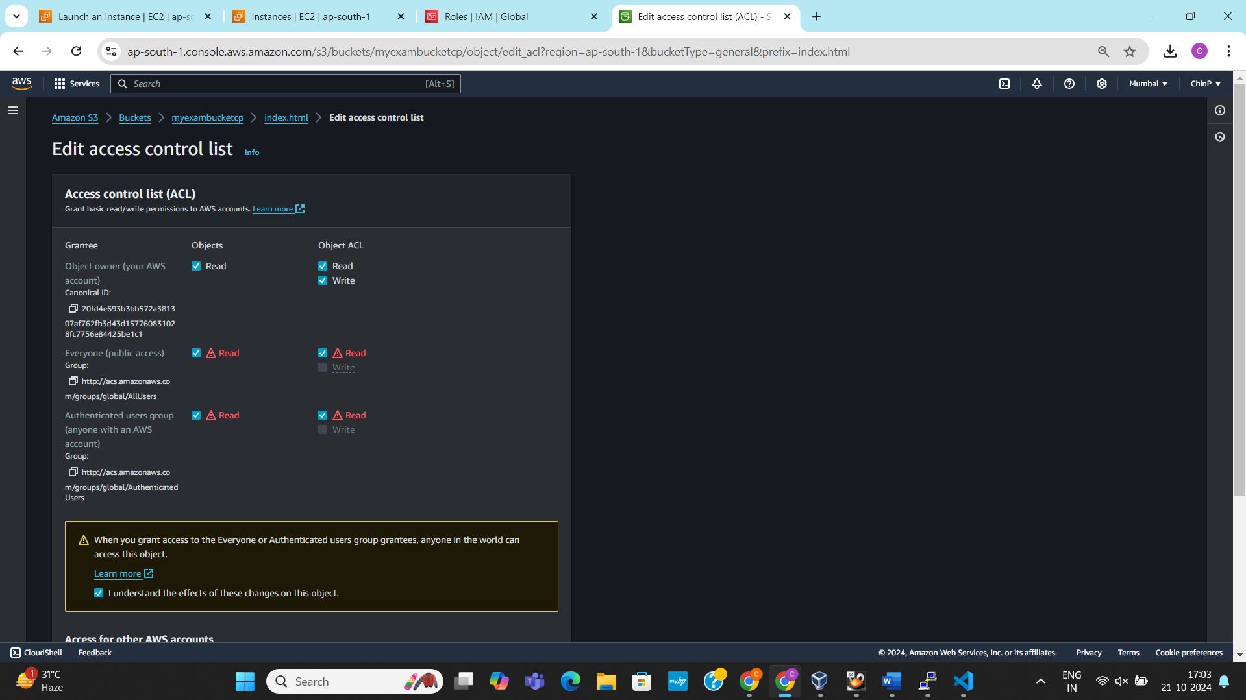

1. Accessing the object URL in the web browser.

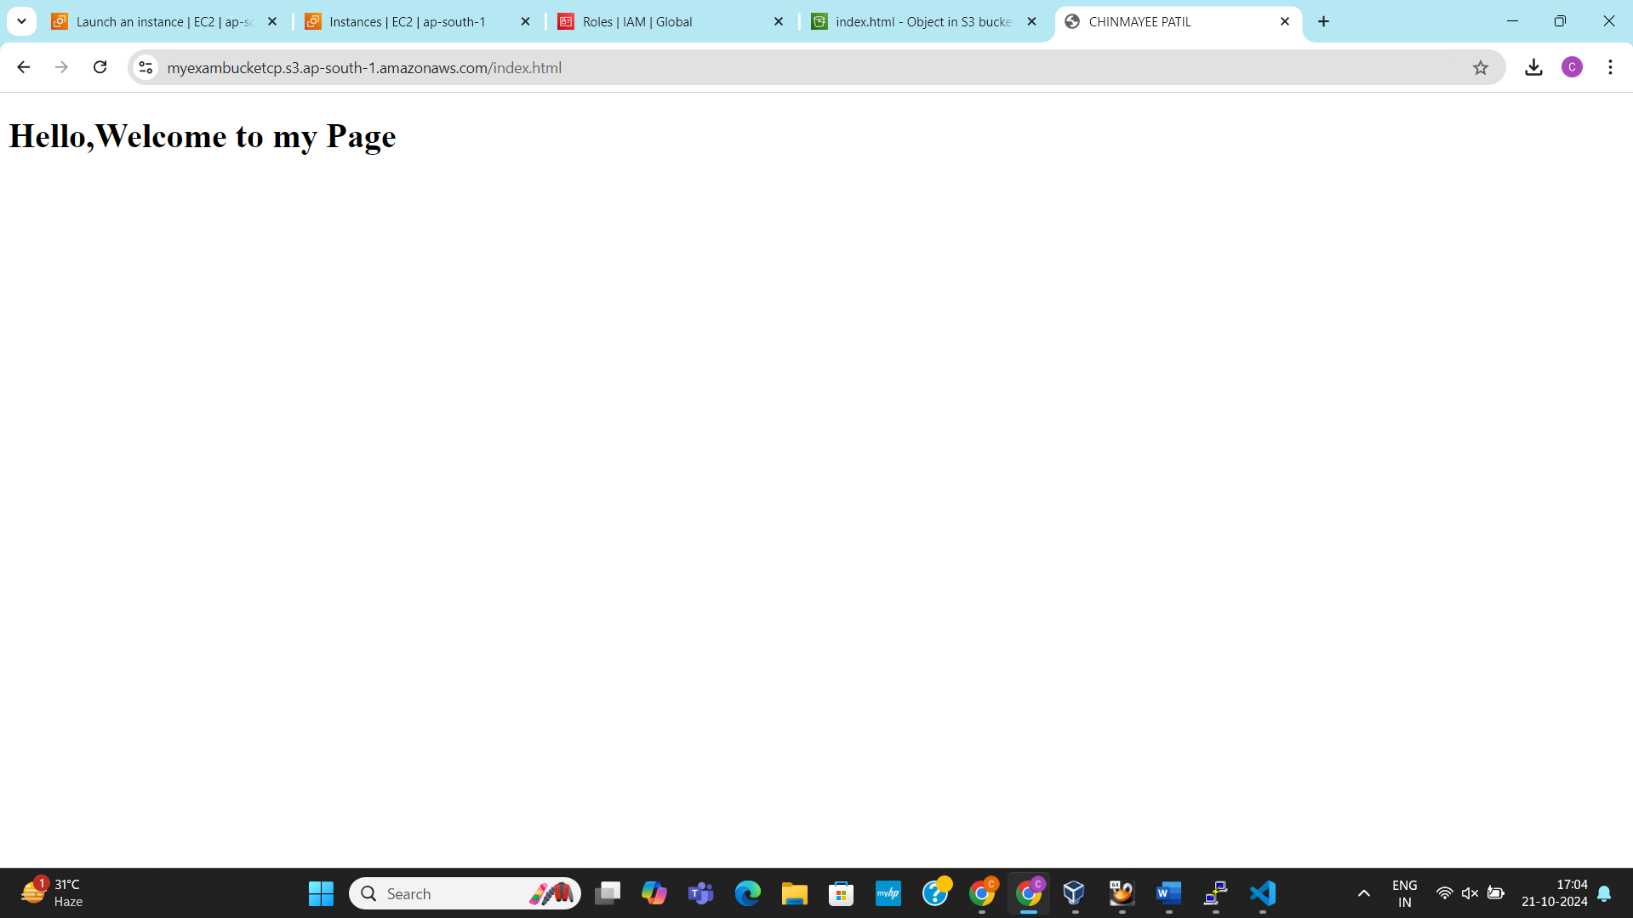

**LINUX**

**Q1.**

1. Largest among 4 numbers.

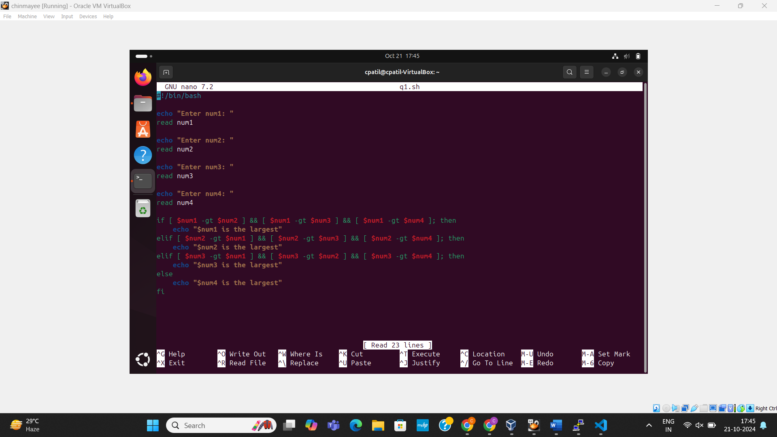

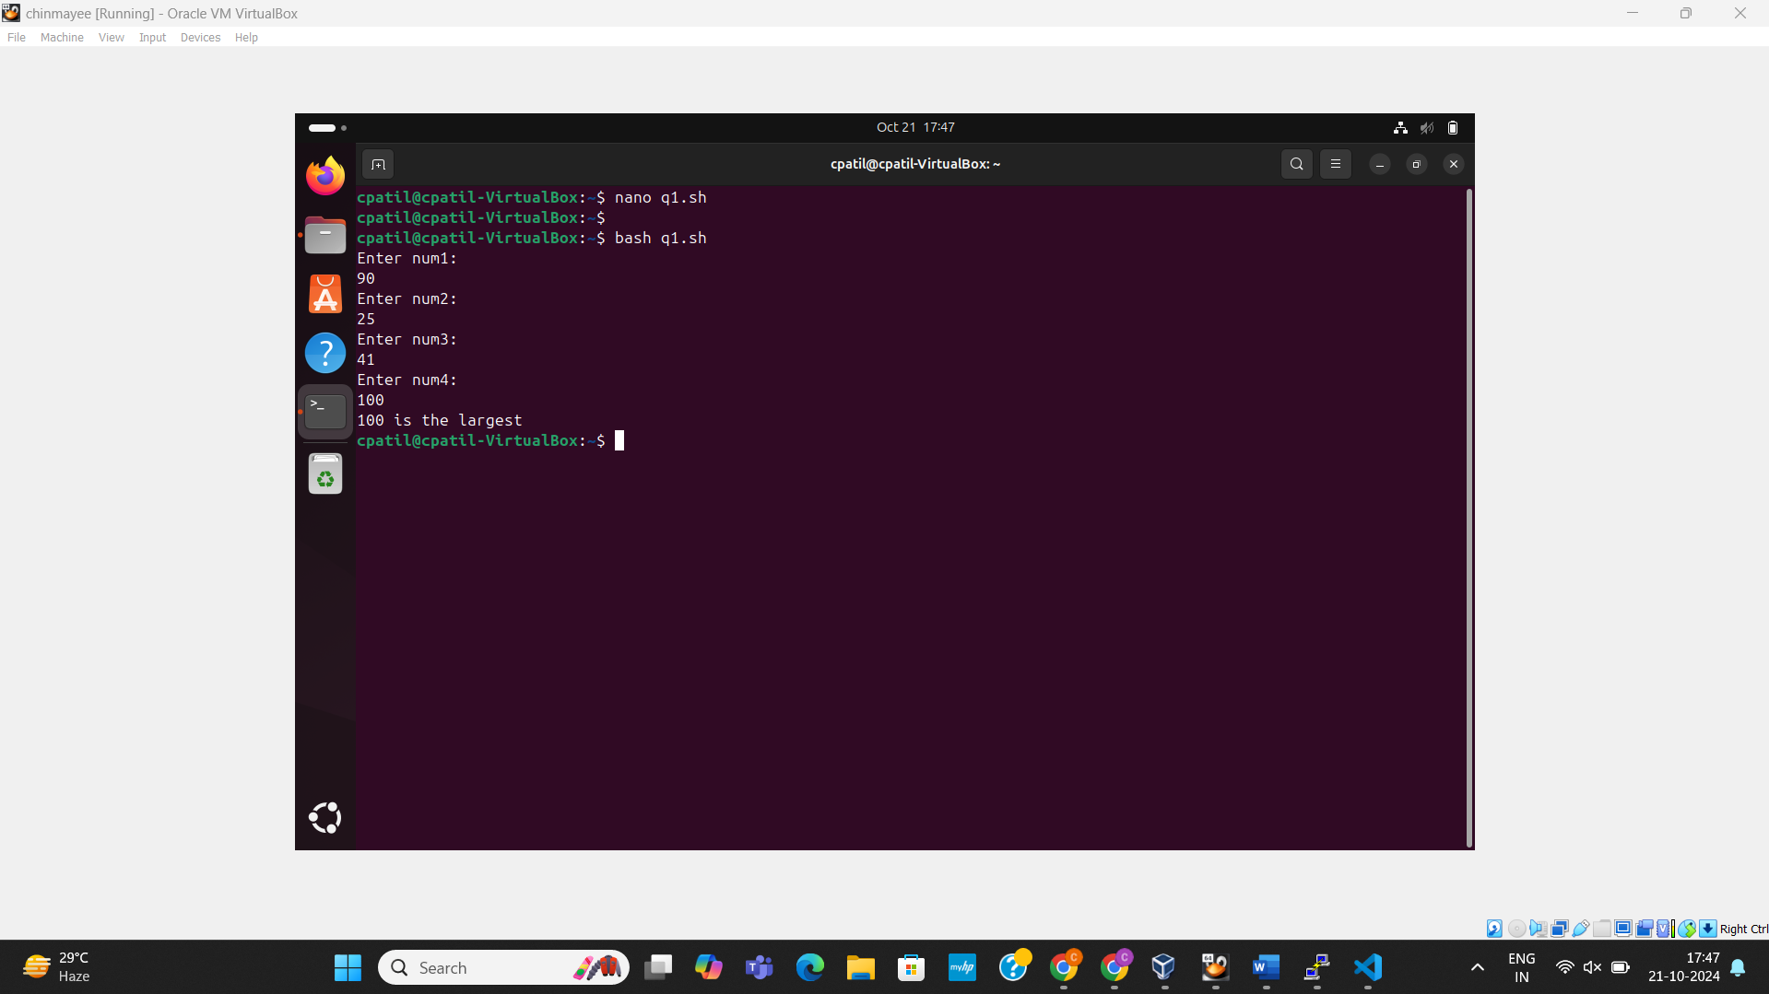

1. Calculating the product of 4 numbers.

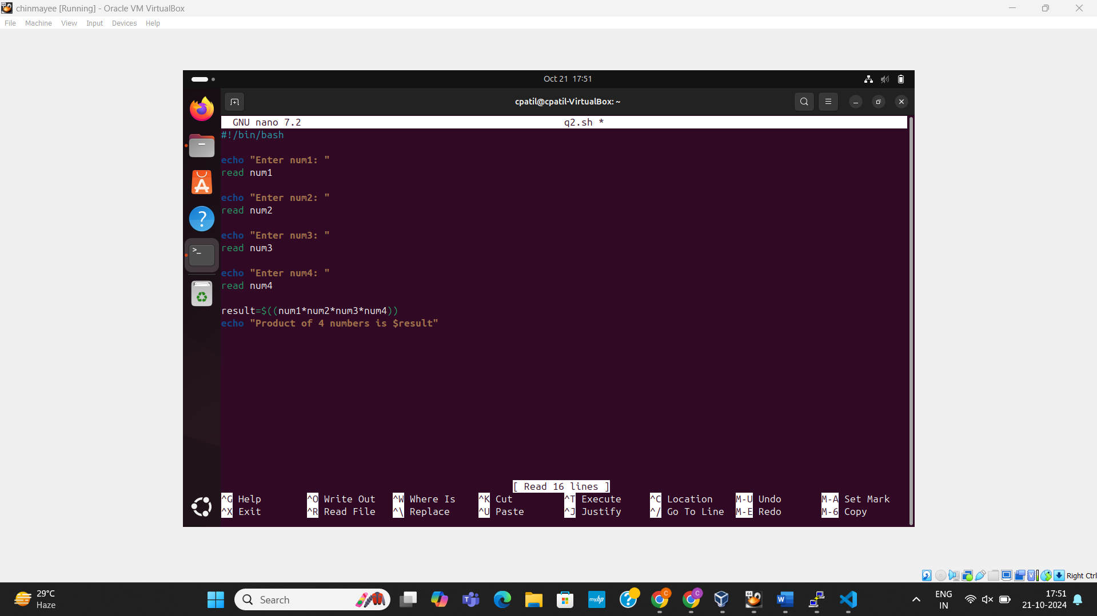

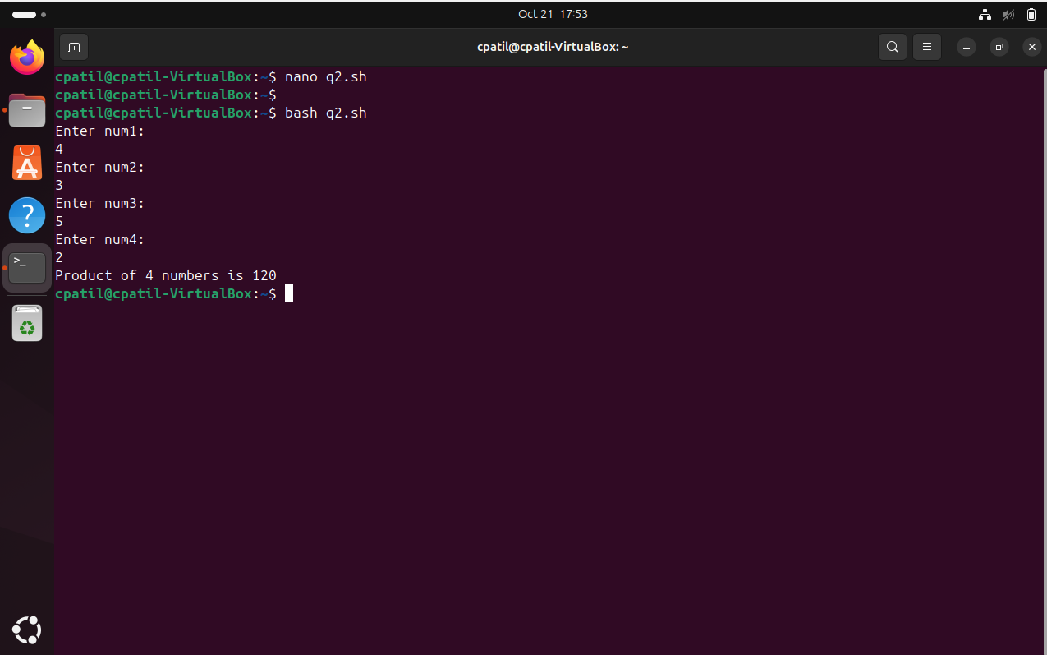

1. Average of 4 numbers

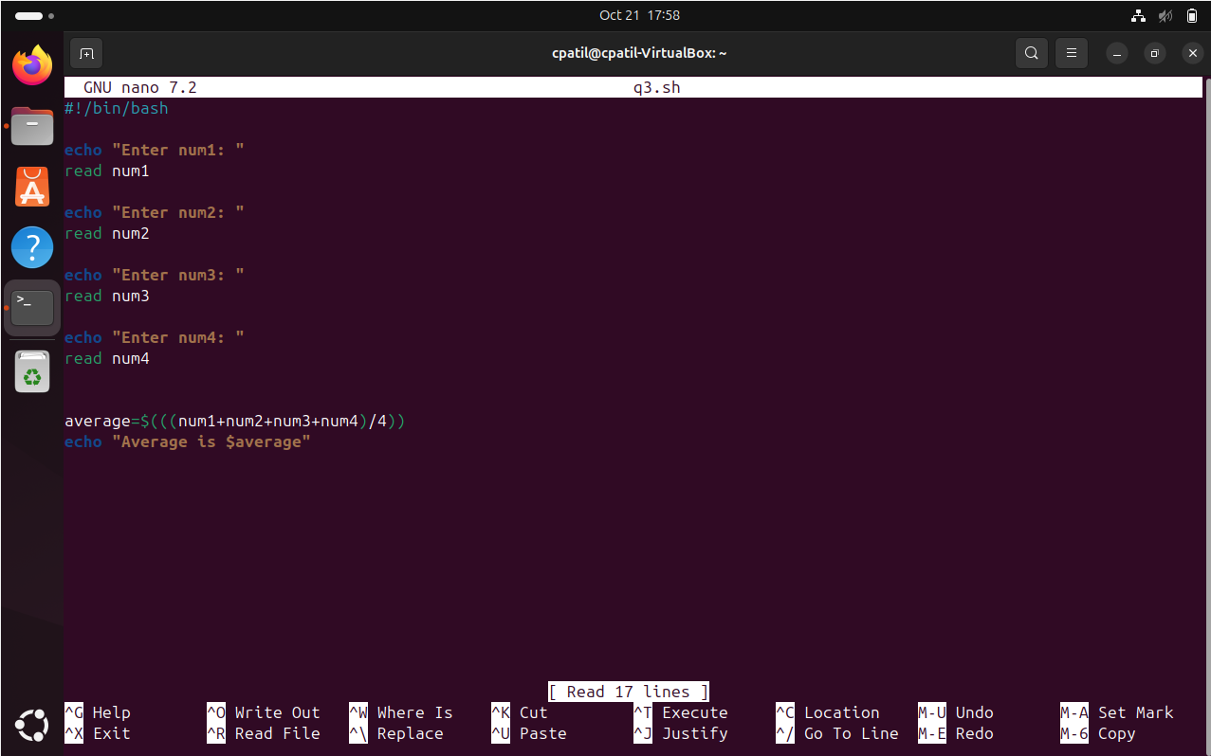

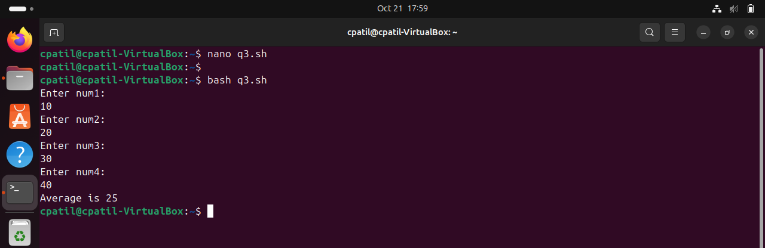

**Q2.**

1. Creating a directory.

Command: mkdir -p moduleexam

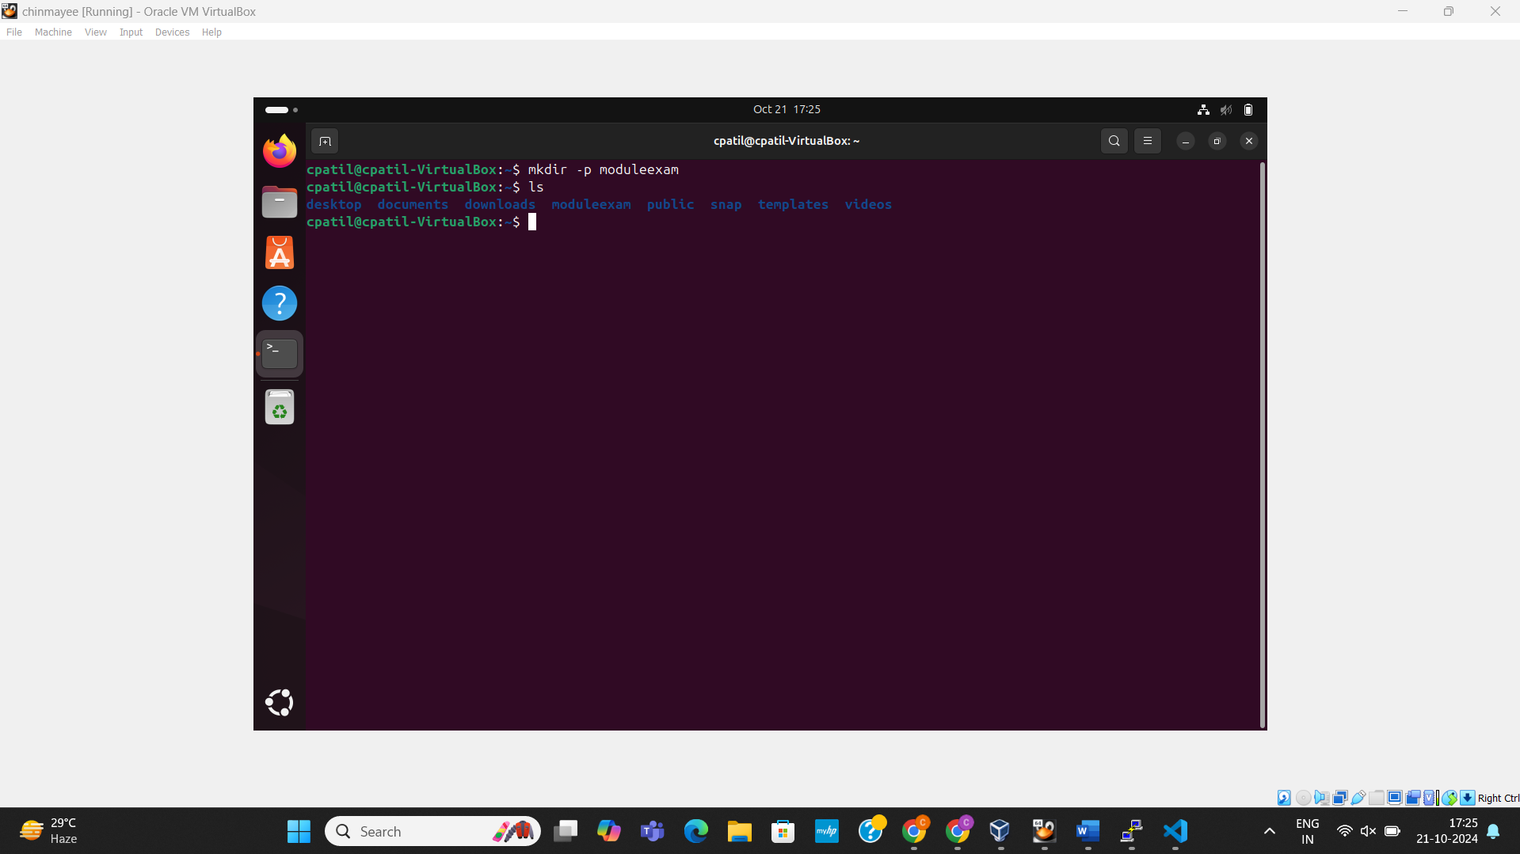

1. Renaming an existing directory with new name.  
   Old directory name – olddir  
   Using mv command renamed olddir to newdirname.

Command: mv olddir newdirname

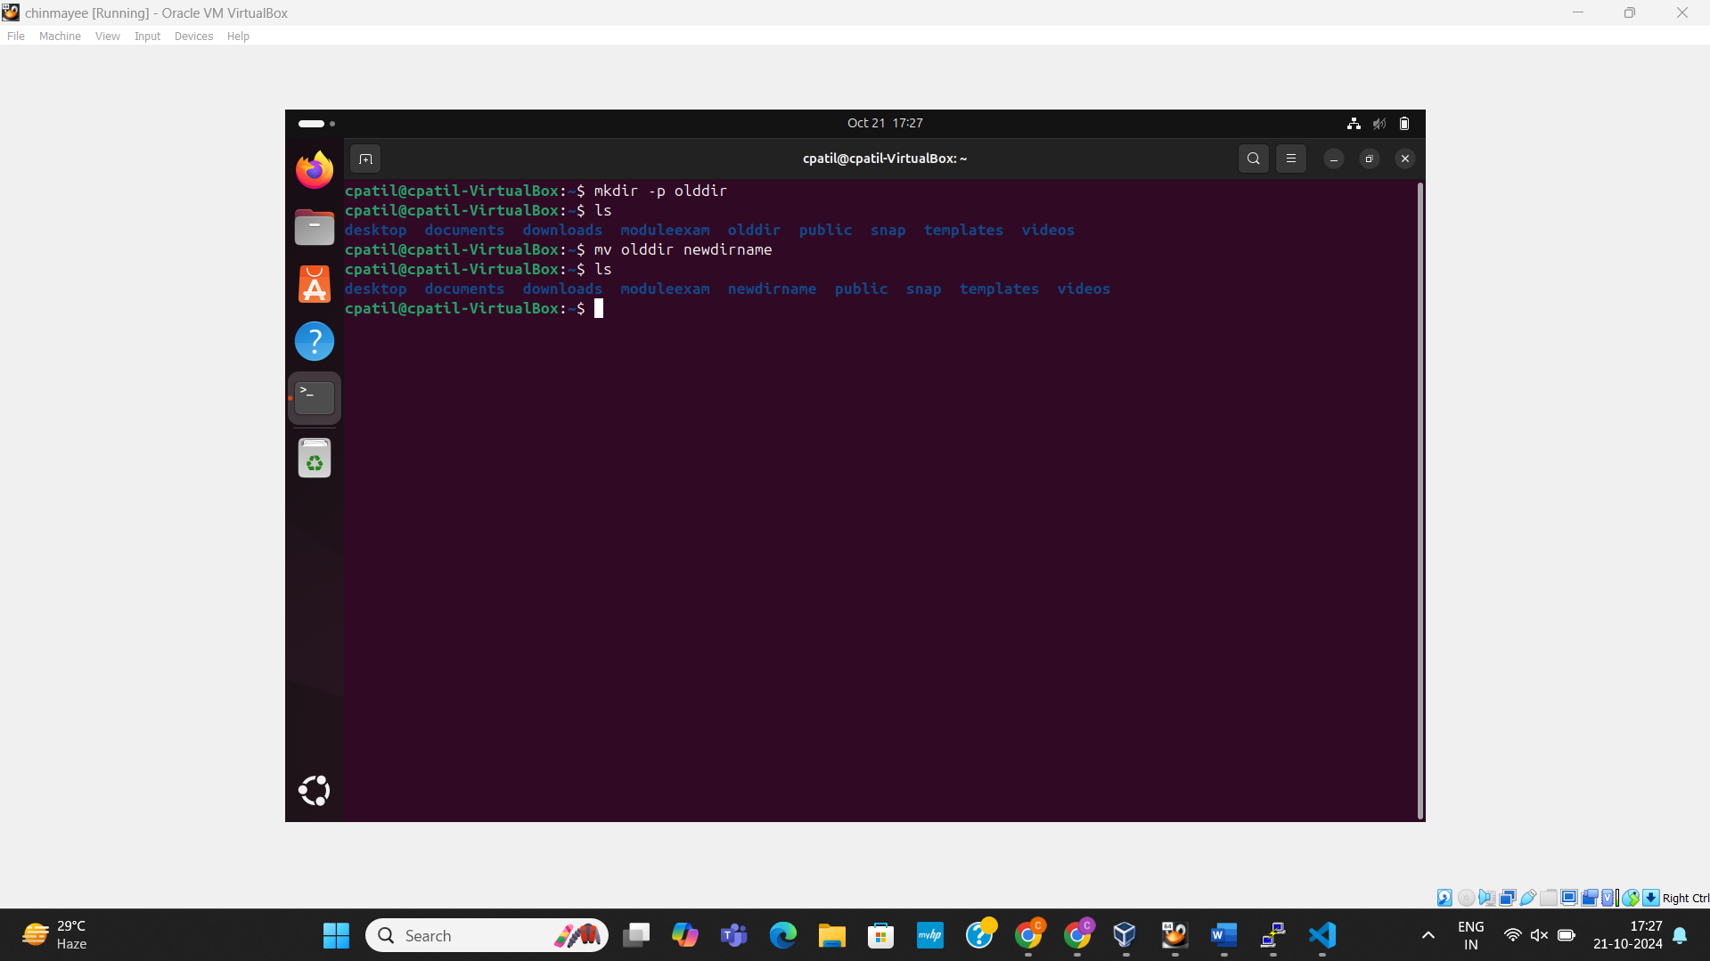

1. Moving an existing directory to new location  
   Q3 is an existing directory.  
   Used command mv to move the directory named newdirname to new directory Q3.  
   Command: mv newdirname Q3

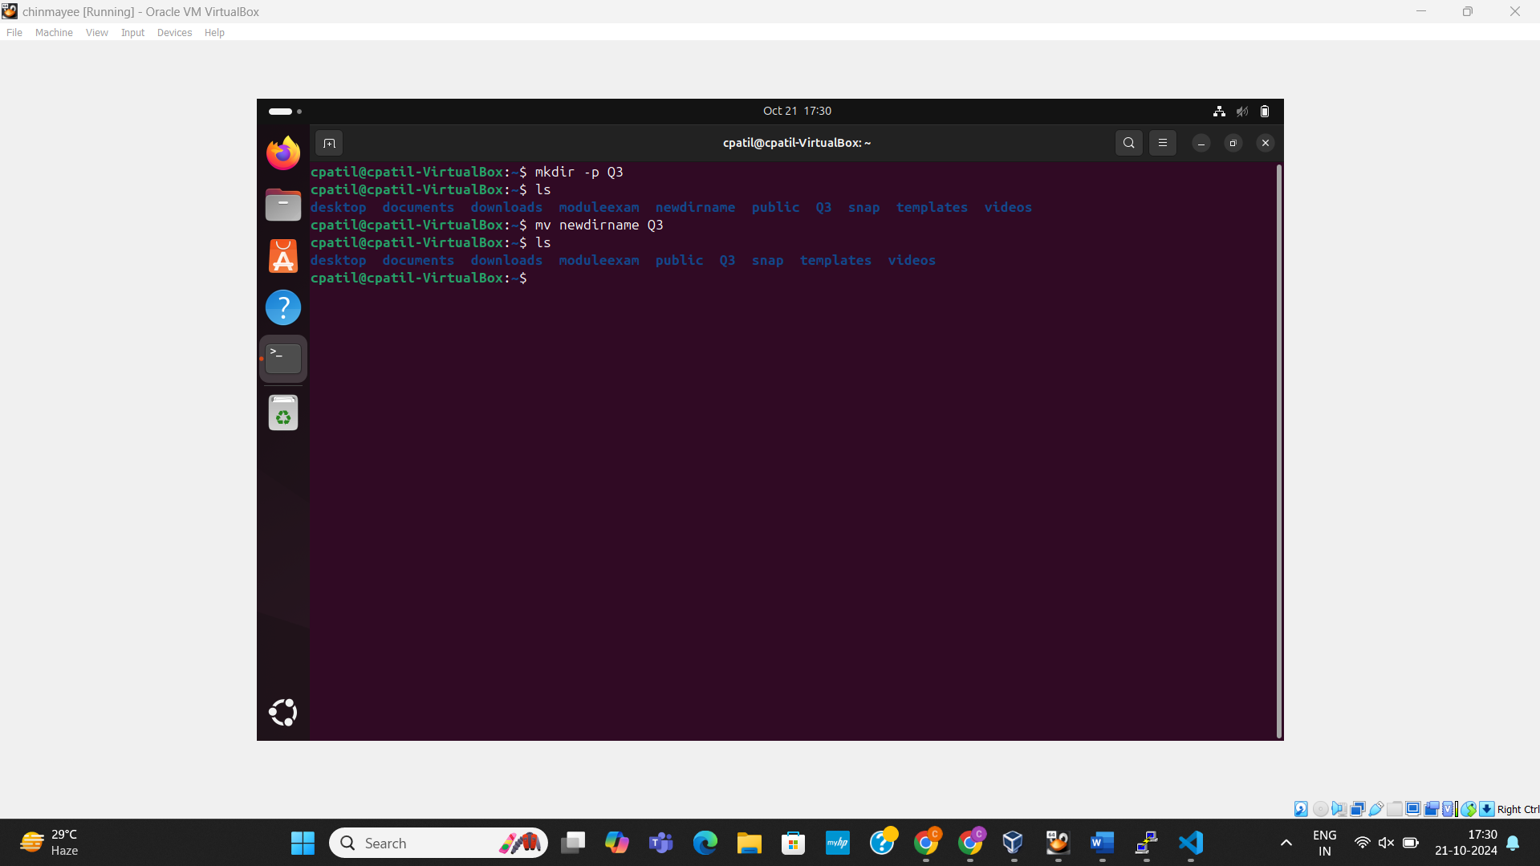

1. Deleting an existing directory

To delete directory we use the command rmdir directory_name.

Deleted the directory named moduleexam  
Command: rmdir moduleexam

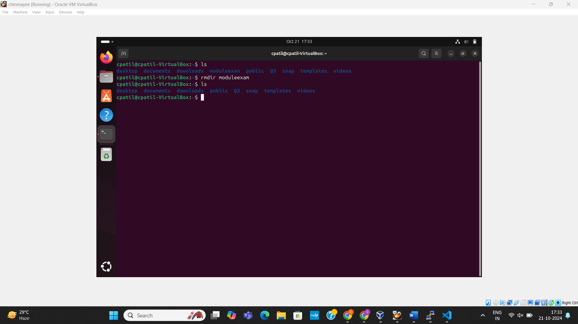

1. Hardlink

Created a file name file1.txt   
Hardlink file name newhardfile1.txt

Command: ln file1.txt newhardfile1.txt

